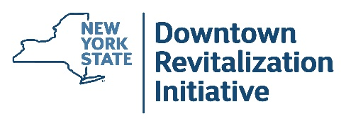
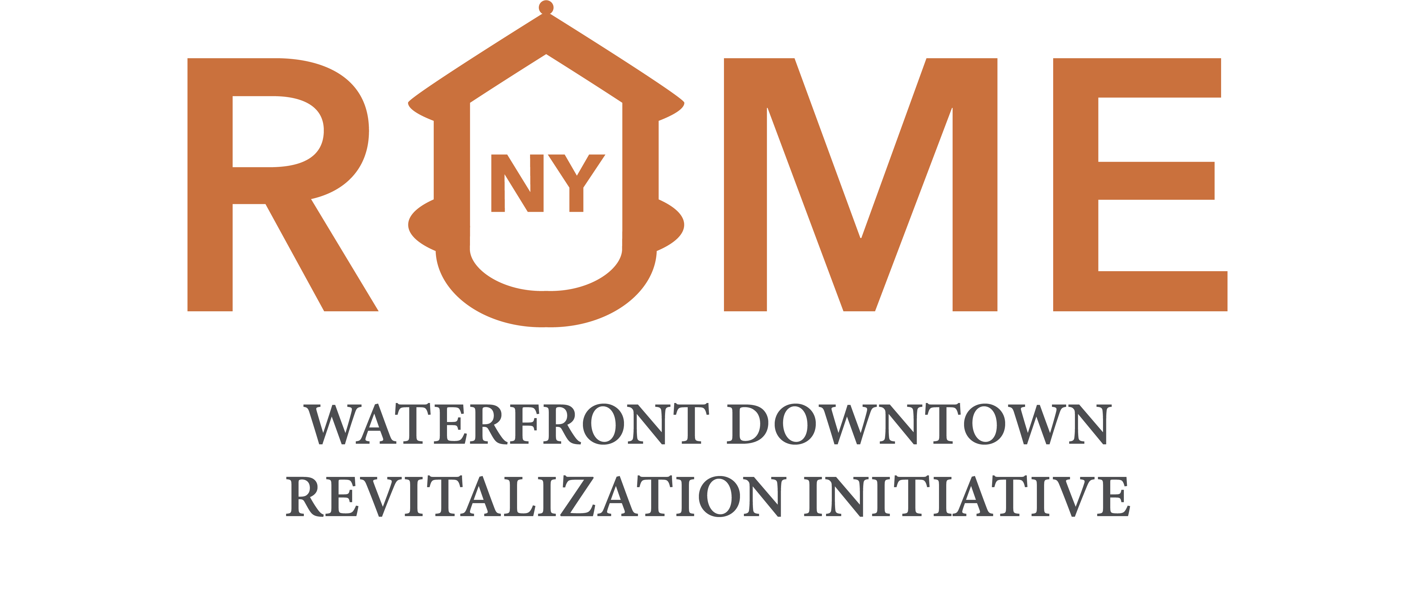

Small Project Fund Interest Form

Do you own a business or property in the Rome Waterfront Downtown Revitalization Initiative (DRI) boundary (below)?

Do you have a building or business in need of smaller-scale improvements such as interior and exterior renovations or permanent equipment acquisition?

The Small Project Fund is a type of DRI project that could help fund a range of improvements in a DRI Area, such as building improvements (e.g., facades, interior fit-out, HVAC, etc.), business assistance (e.g., permanent equipment acquisition), or public art.

For the Small Project Fund to be considered, it is required to document potential interest. The Rome DRI Local Planning Committee is seeking letters of interest from businesses and/or property owners to demonstrate local interest in participating in this program. To learn more about eligibility for the Small Project Fund, go to this website https://hcr.ny.gov/system/files/documents/2026/06/small-project-fund-administrative-plan-sample.pdf

Please submit your letter of interest (pages 4-5) by August 28th at 5:00 pm

 To submit via email:  Email your completed letter of interest to Aidan McKibbin at romenydri@gmail.com |  To submit a hard copy, mail or hand-deliver to:  ATTN: Matthew Andrews  Rome City Hall  198 N Washington St.  Rome, NY 13440  Open: 8:30 - 4:30 pm

Please note that submitting a letter of interest does not amount to an application for funding or guarantee that a community will apply for a Small Project Fund as part of the DRI. Submitting a letter also does not commit the signatory to applying to the Small Project Fund should one be awarded. Additional information about eligibility and requirements for a potential Small Project Fund can be found below.

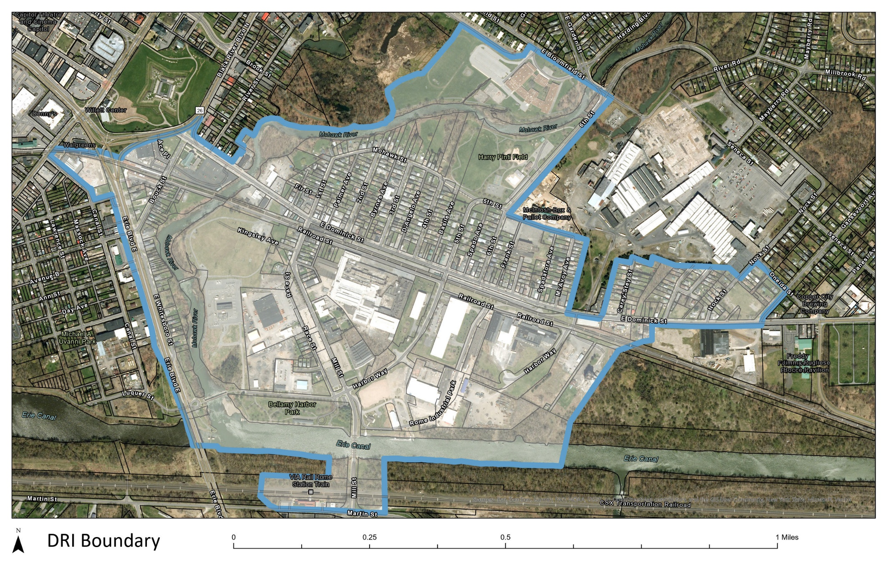

Small Project Fund Eligibility Requirements & Conditions

Eligible activities include:
- Interior and exterior building renovations for commercial and mixed-use spaces, e.g. façade/ storefront renovations, permanently affixed signage and awnings, commercial interior fit-out, HVAC, mechanical, electrical, or plumbing, and other permanent building improvements
- Upper-story residential improvements
- Business assistance / permanent commercial machinery and equipment
- Soft costs - architecture, engineering, and environmental review services as related to the improvements
- Public art

Ineligible activities include:
- Property acquisition
- Deferred maintenance or general repairs
- Working capital
- Landscaping
- Improvements to municipally owned or operated buildings
- Participant, participant’s family, or participant’s staff labor

Conditions
- The minimum match requirement is 25% of the total project cost meaning the business and/or property owner may receive reimbursement up to 75% of total eligible costs.
- This is a reimbursement program meaning that property or business owners must complete their projects (complete project scope, pay all contractors in full, and submit invoices and proof of payment) before receiving any reimbursement.
- Project awards are generally between $25,000 and $100,000 per building/project, with the grant request not to exceed 75% of the total eligible project cost.

Letter of Interest Instructions

Please review the contents on the following pages and fill in the boxes with information specific to your project. Submitting this letter of interest will serve as demonstration of demand for a Small Project Fund.

Questions regarding the Small Project fund can be directed to Aidan McKibbin at romenydri@gmail.com

Small Project Fund Letter of Interest

To the Rome Waterfront DRI Local Planning Committee,

I am writing to confirm my interest in participating in the Rome Waterfront DRI Small Project Fund. I own or lease the property located at

I am interested in making improvements to my property/business, which would contribute to the revitalization of not only my property, but also the DRI Area. The scope of my proposed project includes the following:

I understand the submittal of this letter of interest does not guarantee funding, and I will be required to submit an application to the administering entity of the Fund, if the project is selected for funding through DRI.
$

I anticipate the total project cost to be approximately

I understand I would be eligible for a maximum reimbursement of up to 75% of the total eligible costs. I understand that deferred maintenance and general repairs are not eligible improvements.

Additionally, if awarded, I understand that upon completion of the proposed scope of work, this project will result in a finished space ready for occupancy. I also understand that this is a reimbursement program, meaning I must complete all the work in the approved project scope, pay all contractors in full, and submit invoices and proof of payment before receiving the grant.

My project includes the following activities/improvements and associated estimated costs:

Activity / Improvement | Cost
 | $
 | $
 | $
 | $
 | $
 | $
 | $
 | $
Total project cost | $
Total DRI funding request | $

Without the reimbursement to defray 75% of the project cost, I will be unable to permanently commit this amount of money toward the costs of these improvements.

I realize that to be eligible for these funds, I will need to undertake these improvements in cooperation with the Rome design guidelines and building and zoning codes, as applicable, State procurement and environmental requirements, and complete the work in a timely manner, within 36 months of the State’s grant announcement.

Name
Address
Signature

