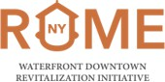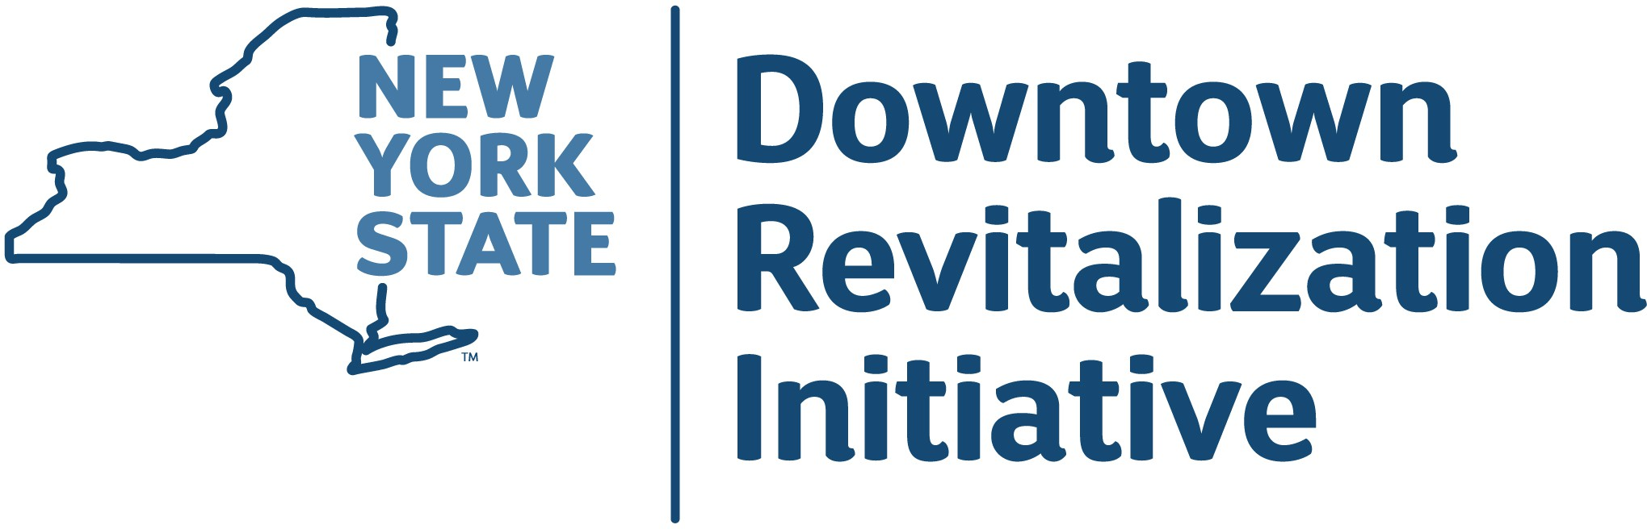
Rome Waterfront DRI

Call for Projects Submission Form
The City of Rome has been awarded $10 million through the New York State Downtown Revitalization Initiative (DRI) to fund catalytic projects in the Waterfront DRI area to spur revitalization. The Local Planning Committee (LPC) is seeking project proposals for potential projects to be included in Rome's Strategic Investment Plan. Projects included in the Strategic Investment Plan will be reviewed by New York State and may receive funding. Project proposals must be received by:
August 28th, 2026 by 5:00 p.m.

Support for Project Sponsors preparing submissions
As part of the DRI award, the community has access to a DRI consultant team who will be supporting the development of the Strategic Investment Plan including the identification of potential projects and development of project profiles. This team will work closely with the LPC, state partners, and project sponsors.

- Live Informational Webinar
A live informational meeting about the Open Call for Projects and eligibility requirements will be held

July 21 at 12:00 pm (Zoom)
Please visit romenydri.com to register, or afterward, to view the recorded webinar.
- Pre-Application Meeting
Project Sponsors interested in submitting a proposal should meet with the DRI consultant team early on
for proposal review and support prior to submitting a proposal.
** Please email your name, contact information and a few sentences about your project to: romenydri@gmail.com with the subject line "Rome DRI Open Call" to request a meeting with the DRI consultant team.
- Additional Project Support
The DRI consultant team is available for one-on-one consultations throughout the open call period. Please email the team per the instructions above to arrange a call.

Important Deadlines & Timeframes
The following describes the deadlines and process for submitting and developing a project for the DRI. The dates are subject to change, please check the website romenydri.com for the most up-to-date information.
July 9 | Local Planning Committee Meeting (LPC) #1. Introduction to the DRI planning process, including the Open Call for Projects and project selection process.
July 11 -  August 28 | Open Call for Projects  Applicant Support: Informational Webinar July 21 and Pre-Application meeting plus ongoing support - see cover page.
August 11 or September 10 | Decarbonization 101 Webinar. If you want to learn more about how to make your building more efficient, this webinar will provide strategies for decarbonizing your building. Please note that some substantial building projects will be required to incorporate decarbonization.
August | Public Workshop #1 The DRI planning process is introduced to the public, with opportunities to comment on the Rome Waterfront DRI vision and goals.
August 12 | Local Planning Committee Meeting #2. The LPC will discuss the downtown assessment, DRI vision and goals, and stakeholder input.
August 28 | Proposal Submission Deadline. Submission of project proposal and all supporting documentation via email or in-person hard copy. It is important to define the scope of work, decarbonization scope, budget, and funding sources prior to submission.
August 20 | Historic Preservation Webinar. All projects receiving State funding are required to consult with the State Historic Preservation Office (SHPO). Attend this webinar to learn if SHPO review may affect your project.
mid-August -  mid-October | LPC #3 and LPC #4 - Initial Project Review. The LPC may remove projects from further consideration. The DRI consultant team will follow up with project sponsors to address LPC questions and comments, and be available for further sponsor consultation. Sponsors may refine their proposals and submit supporting documents as needed. Project Sponsors must respond promptly to inquiries.
October | Final Project Information Deadline. Final scope of work, decarbonization scope, detailed budget, proof of funding, and additional supporting documentation is required.
Oct - Nov | LPC Final Project Evaluation and Recommendation (LPC #5) – LPC will select a list of projects to recommend to the state for funding.
December | Strategic Investment Plan submitted to the State.
2027 | Project Award Announcement. Awarded projects are announced. Funds spent BEFORE the announcements are not eligible for reimbursement.
2027 - 2028 | Contracting and Start of Construction. Awarded projects will contract with a State agency and will progress the project to construction or implementation.

How to Submit Your Project

Review the Eligibility Criteria and Project Requirements
1
on pages 3-5 to learn about requirements for projects and to make sure your project is eligible to be considered for DRI funding.

Review the Vision, State Goals, and Evaluation Criteria
2
on page 6 to learn about the vision and goals for Rome's DRI area and about how the Local Planning Committee (LPC) and State will evaluate projects. Stay up to date with the process and refer to the draft and final vision and goals on the website to ensure your project is consistent with the vision and goals for the DRI area.
3

Consider consulting with an Architect/Engineer/General Contractor/ Vendor
as required to help define the project scope of work, review the existing conditions, identify code requirements and design feasibility, and develop realistic budgets. Contact the DRI consultant team for guidance and assistance.

Attend the Open Call Informational Webinar and set up a one on one meeting with the DRI Consultant Team
4
to learn more about the process and project requirements. Email your name, contact information and a few sentences about your project to: romenydri@gmail.com with the subject line "Rome DRI Open Call" to schedule a meeting with the DRI consultant team.
5

Fill out the Project Form
on pages 7-21. Address each topic thoroughly and completely. The LPC will use this information to evaluate projects to potentially be included in the Rome Waterfront DRI Strategic Investment Plan.
6

Submit your Completed Application
Submit your completed application including supplemental materials either electronically
or as a hard-copy no later than August 28th, 2026 at 5:00 p.m.


To submit via email:
Email your completed application and any supplemental materials to romenydri@gmail.com

*You will receive a confirmation email shortly after submitting. Please contact this email as needed to arrange for delivery of extra large (over 20 MB) file attachments

To submit a hard copy, mail or hand-deliver to:
Matthew Andrews Rome City Hall
198 N Washington St. Rome, NY 13440

**Open: 8:30 - 4:30 pm
*If submitting a hard copy, please ensure all text is visible. Please move overflow text to a new page if needed before printing.

Questions regarding project eligibility, evaluation, or the project forms can be directed to the DRI consulting team at
?
at romenydri@gmail.com

Project Types & Requirements
It is expected that DRI funds will be used for capital projects that will transform the physical environment of the DRI Area in ways that will benefit current residents and future generations. However, certain non-capital projects or projects that may lead to capital investment will also be considered to the extent that they will contribute to the revitalization of the DRI Area. The following is a description of eligible and ineligible project types.

Eligible Project Types

- Public Improvement Projects. These may include projects such as streetscape and transportation improvements, recreational trails, wayfinding signage, new and upgraded parks, plazas, public art, green infrastructure, and other public realm projects that will contribute to the revitalization of the DRI Area. *Typically sponsored by or in partnership with the City.
- New Development and/or Rehabilitation of Existing Downtown Buildings. Projects in this category may include the development or redevelopment of real property for mixed-use, commercial, residential, not-for-profit, or public uses. Projects should have a visible and functional impact on the DRI Area, serving as catalytic or transformative projects that will provide employment opportunities, housing choices, and/or services for the community. *These may be sponsored by private entities including for-profit or not-for-profit entities.
- Small Project Fund. A locally managed matching small project fund may be proposed to undertake a range of smaller projects in the DRI Area such as facade enhancements, building renovation improvements to commercial or mixed-use spaces, business assistance, or public art. Funds are capped at $600,000. *Please see the Small Project Fund Letter of Interest on the Rome DRI website to submit your expression of interest for a small project.
- Branding and Marketing. Examples include branding and marketing projects that may target residents, investors, developers, tourists, and/or visitors. The costs eligible under this category must be one-time expenses, such as those to develop marketing materials. This project type is intended for the overall branding and marketing of a DRI Area, not to provide branding and marketing services to individual area businesses or other entities.
Ineligible Project Types
- Planning activities. Following the preparation of the Strategic Investment Plan, all CRI funds must be used for projects that directly implement the plan.
- Operations and maintenance. CRI funds cannot be used for on-going or routine expenses, such as staff salaries and wages, rent, utilities, and property upkeep.
- Pre-award costs. Reimbursement for costs incurred before the completion of the Strategic Investment Plan and the announcement of funding awards is not permitted.
- Property acquisition. The cost of property acquisition can be included in the overall project budget, but the acquisition must be funded by another funding source.
- Training and other program expenses. The CRI program is a one-time infusion of funds and cannot be used to cover continuous costs, such as training costs and expensed related to existing programs.
- Expenses related to existing programs. DRI funds cannot be used to supplement existing programs or replace existing resources.

Project Requirements
The following are the requirements for projects to be considered for DRI funding. Recognizing several requirements must be met to qualify for DRI funding, each project sponsor will have access to technical support from State agencies and a consultant team to assist with project development (i.e. construction cost estimates, renderings, climate resilient design, meeting decarbonization requirements, etc).

  - Project Location. Projects must be located within the DRI boundary. If your project is located outside the DRI boundary, please provide a brief description of how the project relates to the DRI Area and supports the stated goals of the DRI. Minor boundary modifications may be considered by the LPC.
  - Project Timing. Projects must be able to break ground within two years or sooner of receiving DRI funding.
  - Project Size and Scale. Projects must be large enough to be truly transformative for the DRI area. Standalone DRI projects must be at least
$250,000 in total project cost. For smaller projects, please see the Small Project Letter of Interest form on the Rome DRI website. If you are seeking to submit a project that is less than
$250,000 as a DRI project, please contact the DRI consultant team at romenydri@gmail.com for more information.
- Project Funding. Projects should have financial commitments largely secured or be able to demonstrate a clear path to securing sufficient financing. For projects with a private sponsor, there is a minimum matching funds requirement of 40% of the total project cost. For public and non-profit projects, there is a minimum matching funds requirement of 20% of the total project cost. Anyone with a project that does not meet these minimums should contact the DRI consultant to discuss options (romenydri@gmail.com). Projects that leverage additional matching funding sources above the minimum requirement will be more competitive.
- Project Sponsors. Every project must have an identified project sponsor. Sponsors may be public, not-for-profit, or private entities (not individuals) with the capacity and legal authority to undertake the proposed project. Proposals with project sponsors that are membership-only organizations or religious facilities must propose projects that are available to the public and not just to active members.
- Building Decarbonization. For DRI communities, all public, private, and non-profit projects that meet the criteria for new construction, substantial renovation, or a building addition shall include decarbonization techniques. Each project that meets the criteria will be required to select a method of demonstrating that the project satisfies the requirements. Please contact the DRI consultant team for more information. More information on this requirement can also be found on page 77 of the DRI Guidebook.

If your project does not meet all of the criteria described in this section, we still want to hear your project idea! Please share your ideas at RomeNYDRI.com.
Decarbonization and Historic Preservation Webinars
Certain projects funded through DRI will be required to meet the program’s decarbonization standards and consult with the State Historic Preservation Office. Attend the informational webinars to learn about how these program aspects may affect your proposed project.
Decarbonization 101 Webinars | DRI and Historic Preservation Webinar
August 11th at 11 AM or  September 10th at 1 PM  Registration Link: https://meetny-gov.webex.com/webappng/sites/meetny-gov/webinar/webinarSeries/register/61429d52b30f46ccad0567bd31d65a23 | August 20th at 1 PM  Registration Link: https://meetny-gov.webex.com/weblink/register/r998ba6da5d2965761f4c93781554c7ff

Rome Waterfront DRI Draft Boundary
[Provide Map of DRI/NY Forward Boundary]
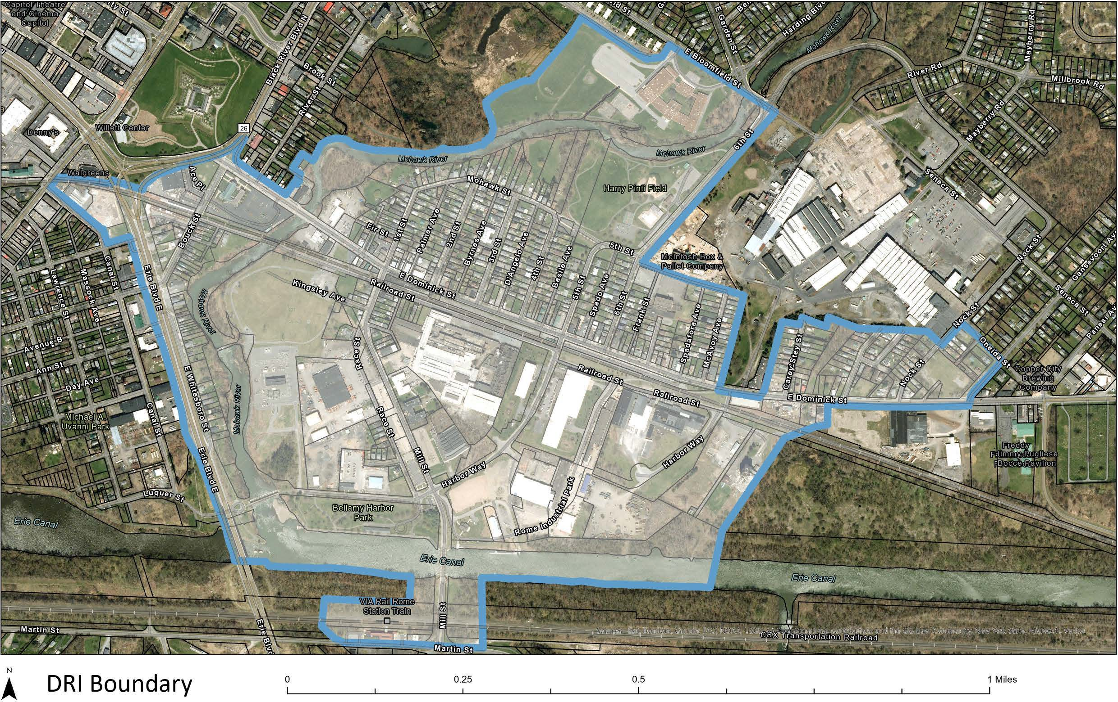

Rome Waterfront DRI Vision, Goals & Evaluation Criteria
Projects should align with the Rome Waterfront DRI vision. The following is the draft vision for the Rome Waterfront DRI area:

Rome Waterfront DRI Draft Vision

"Rome’s Waterfront District is transforming into a vibrant and welcoming, mixed-use destination. Building on its Erie Canal, Mohawk River, and industrial heritage, the district will connect recreation, housing, businesses, dining, and public spaces to support residents, employees, and visitors. By offering places to gather, live, work, and play year-round for all ages and abilities, the district will enhance community pride, quality of life, and Rome’s appeal as a regional destination.

Additional Project Evaluation Criteria
Catalytic Effect. The project is likely to have a significant positive impact on the revitalization of the DRI Area by attracting other public and private investment at a scale appropriate for Rome.
Project Readiness. The project should be well-developed and poised to proceed in the near-term in a way that will jump start the redevelopment of the DRI area.
Cost Effectiveness. Investment of DRI funds in the project would represent an effective and efficient use of public resources.
Co-Benefits. The project will result in secondary benefits to both the community and project developer, beyond the primary goal of the project itself, which will generate additional economic activity, grow the local property tax base, improve quality of life in the neighborhood, and/or result in improved buildings likely to create healthier, more comfortable, and productive environments in which to live and work.

Alignment with State DRI Goals.
  - Create an active downtown with a strong sense of place.
  - Attract new businesses that create a robust mix of shopping, entertainment and service options for residents and visitors, and that provide job opportunities for a variety of skills and salaries.
  - Enhance public spaces for arts and cultural events that serve the existing members of the
community but also draw in visitors from around the region.
  - Build a diverse population, with residents and workers supported by complementary diverse housing and employment opportunities.
  - Grow the local property tax base.
  - Provide amenities that support and enhance downtown living and quality of life.
  - Reduce greenhouse gas emissions and support investments that are more resilient to future climate change impacts.

Rome Waterfront DRI Project Form
Please complete this form in order for your project to be considered by the LPC and potentially be eligible for Rome Waterfront DRI funding. Please address each topic thoroughly and completely. The LPC will use this information to consider projects for inclusion in the Rome Waterfront DRI Strategic Investment Plan. Project sponsors are expected to provide timely responses to requests for any additional information from New York State and/or the Rome Waterfront DRI consultant team. If extra space is needed, please use the additional pages provided at the end, or attach additional pages.

Project Type
Please indicate your project type (place an X in the box):

Public Improvement (typically by or partnered with the City of Rome)
New Development
Redevelopment and/or Renovation of an Existing Building(s)
Small Project (Less than $250,000 in Total Cost)
*If you are interested in submitting a Small Project, do not complete this form; instead, please use the Small Project Fund Interest Form, which can be found at romenydri.com
Rome Waterfront Branding and Marketing

Project Sponsor
Provide the contact information for the project sponsor, which is the entity proposing to implement the project. The project sponsor can be different from the property owner.
Name:
Sponsor business or organization (if applicable):
Title (if applicable):
Mailing Address:
Phone:
Email:
NYS Tax ID/EIN:
NYS Vendor ID (if applicable):

If there are additional people who should be contacted as part of this proposal, please provide their contact information.
Name:
Phone:
Email:
Affiliation:

Name:
Phone:
Email:
Affiliation:

Project Location
Please indicate the location of the proposed project.
Project Address or Location:
If the project is located outside the Rome Waterfront DRI boundary shown on page 5, please provide a brief description and justification of how the project relates to the DRI Area and supports the stated goals of the DRI program. The LPC may consider minor boundary adjustments.

Existing Conditions and Project Background
Describe the project site’s existing conditions, including a description of why the proposed project is needed. Include any work or planning done previously on the proposed project.

Project Description
Please provide a detailed description of the proposed project’s scope of work, as applicable:
- The proposed use (e.g., commercial, industrial, public improvement, mixed-use). If the use is residential, please specify the estimated number of new units and how many will be affordable (if applicable).
- The goal of the project.
- The size of the project (e.g., square footage of the building and space to be renovated (if applicable), number of floors, acreage, number of units, type of housing, commercial tenants.).
- The types of activities to be completed as part of this project (e.g., sidewalk construction, replacement of flooring, exterior siding, interior walls, plumbing and electricity in upper floors.

It is important to provide as much detail on the proposed scope as possible. The information may be updated as the project becomes more developed. Bullets are ok.

Building Project Square Footage (proposed project footprint):

Please select which activities apply to your project (place an X in the box):

Demolition (removal of part of /entire structure
Exterior changes (windows, siding, storefront
New building construction
Addition to existing building
Interior renovation
Electrical / Plumbing / HVAC
Site work or utility installation (digging, trenching, streetscape, grading)
**Building projects, depending on the scale, may be subject to the DRI decarbonization standards. Please see Page 77 of the DRI Guidebook and speak to the consultant team for more information about which projects are subject to these standards.**
Description

Description Continued:

- Project Alignment with Vision and Goals
How does your proposed project help advance the community’s vision and goals? Please be specific in explaining exactly how your project or components of your project advances the vision and goals.

Property Ownership
Identify the owner of the property on which the proposed project will be located. If the project sponsor and the property owner are not the same, please describe how the project sponsor will obtain the legal authority to implement the project at this site.

Capacity
Describe the project sponsor’s experience in implementing projects similar in scope/complexity to the proposed project, including any experience with grant administration, State grants, and specifically the DRI or NYF programs.
Describe any partner entities or organizations that will help implement the project (e.g., funding, operating, or business partners).

Preliminary Cost Estimate

What is the total estimated project cost and the amount of DRI funds requested?

Total Project Cost: | $
DRI Request Total: | $

The minimum total project cost is $250,000.
The maximum DRI request is 60% of the total project cost (40% match) for private projects and 80% of the total project cost (20% match) for public and non-profit projects.

Projects requesting a lower total project cost or lower match should contact the consultants at romenydri@gmail.com to discuss options. Projects with a match that exceeds the minimum requirement will be more competitive. Please contact the consultant team with any questions.

Please complete the budget table on the following page. Please identify different activities associated with the project, their costs, the funding source, and the status. Please use the following definitions to guide the response for the Budget

Secured: This funding source and amount of funding is guaranteed.

Anticipated: This funding source is reasonably expected to be available at the time of project implementation, but the project sponsor does not have the funds currently available. This status may apply for funding sources such as loans, bonds, or fees.

Requested: The project sponsor has submitted a request to a funding entity for the amount identified but has not received confirmation of funding. This category is appropriate for DRI funding source or other grants.

Undetermined: This funding source has not been secured, and the project sponsor has not fully identified the funding sources and amounts.

Notes: Typical activities included in a construction budget include: architectural and design costs, permit and survey fees, site preparation costs, insurance / bond fees, construction costs, and contingencies.

DRI funds are structured as reimbursable grants. If DRI funds are awarded, the grant recipient may need to finance the total project cost using a bridge loan, owner equity, or another financing mechanism. In this situation, grant funds will be released once the project is completed per the contracted scope of work.

*If a proposed project has not yet developed cost estimates or identified sources of funding, please provide as much detail as possible at this stage.
*A project may include the cost of acquisition in the project budget, but the acquisition must be covered by another funding source, as DRI funds cannot be used to acquire property.

Activities  (add rows if needed) | Cost | Funding source  (DRI or Other, explain) | Status of Funds (Secured, Anticipated, Requested, or Undetermined)
E.g.,: Design Fee | $X,000 | e.g., DRI | Requested
Total DRI funding request | $
Total funds from other sources | $
Total project cost | $

Extra space for explanation, if needed:

Cost Estimate Description
Please describe how your costs were estimated.
For example, were the estimates provided by a third-party contractor or architect?
Please describe the status of non-DRI funds and the timeline for obtaining them.
For example, $X will be provided by private funds. These funds are anticipated to be secured through a loan from XYZ bank by X date. Letters of commitment or other proof of funds may be attached as supplemental information.

Project Readiness and Timeframe for Implementation
Describe any work that is underway or has already been completed to advance the project, such as feasibility studies, market studies, business plans, preliminary site design, permits obtained, and/or funding or financing that has been secured. If studies have been completed, please submit those with this form.
Is the property listed, or eligible to be listed, on the National Historic Register of Places? (place an X in the appropriate box)
 | Yes |  | No |  | Not Sure
Check the CRIS website to determine the status of your property - https://cris.parks.ny.gov/

Fill out / update the proposed timeline for project implementation by milestone, as applicable.

Project Stage | Timeframe (in Months) and Responsible Party
Project Financing
Sketch Plan / Preliminary Design
Regulatory Approvals (Permitting and Approvals)
Design, Engineering and Selection of Contractor
Construction or Implementation
Other

Describe the proposed timeline for project implementation, including major project milestones, as applicable
Is there any environmental investigation or cleanup needed for the project to proceed? If yes, please explain.
If known, please list the permits or approvals your proposed project will require.
What challenges or issues, if any, would affect the implementation of your proposed project?

12. Required Documents
Please include images of the existing project site or building (interior and/or exterior). The images provided must be of the space where project work is proposed. These can be submitted electronically or as a hard copy.

13. Additional Information
The following documents may be provided, if you have them readily available. Inclusion of the documents helps to demonstrate that your project is feasible and ready to be implemented in the short term. Please place an X in the corresponding box to indicate the supplemental information you are providing with this application.

This information can be submitted electronically or as a hard copy. Include the project address and sponsor contact information on each page of supplemental information. If you are submitting supplemental information that is confidential, please label it as such.

Please note that while these additional documents are not required at the time of proposal submittal, those marked with an asterisk, at a minimum, will be required prior to LPC Meeting #4 in order for the LPC to properly evaluate the project for readiness.

Images/renderings of the proposed project*
Construction cost estimates / quotes from contractors*
Letter(s) of support/commitment from financial institutions*
Documentation of commitment from other funding entities
Memorandum of Understanding (MOUs) or Agreements
Business Plans / Market Studies / Pro-forma Analyses
List of Anticipated Permits / Approvals / Variances
(please add copies of documents, if available)
Property Survey
Letter of support from the Property Owner (or current lease terms)
Other (please specify):

Certifications
I hereby certify that the information provided in this form is true and correct to the best of my knowledge. In order to be considered for DRI funding, I understand that additional information may be requested about the project and it may involve meeting(s) with the DRI consultant. I agree to provide the requested information in a timely manner in order for the LPC, DRI consultant team, and State team to evaluate my project.

Project Sponsor Signature:

Date:

I understand that submission of this form does not constitute an application for or guarantee of funding from New York State, that the information provided herein will be reviewed and considered by the Rome Waterfront DRI Local Planning Committee for possible inclusion in the Rome Waterfront DRI Strategic Investment Plan. I further understand that inclusion in the Rome Waterfront DRI Strategic Investment Plan does not constitute a guarantee of funding from New York State, that all funding
decisions will be made by New York State, and if funded I will comply with all State funding requirements.

Project Sponsor Signature:

Date:

Further, I hereby acknowledge that I have read the DRI project criteria and understand that any DRI funding provided for projects will be made available on a reimbursement basis only after expenses are incurred or in some cases, after a project has been successfully completed in its entirety. I also understand that DRI funding will be subject to all applicable New York State requirements, including, but not limited to Minority and Women Business Enterprise (MWBE) utilization, competitive procurement for goods and services, and project status reporting.

Project Sponsor Signature:

Date:

- To submit via email:
Email your completed application and any supplemental materials to Aidan McKibbin at romenydri@gmail.com
- To submit a hard copy, mail or hand-deliver to:
Matthew Andrews
Rome City Hall
198 N Washington St.
Rome, NY 13440
*Open: 8:30 - 4:30 pm
Deadline for Submission:
21
August 28th, 2026 at 5:00 p.m.

Additional space (if needed):
Please include additional information here, if needed. Please note which question or requirement is being addressed.

